GridTalk (Inovis)

Deployment Guide

For

GridTalk Loopback Tester

[Version 1.0.1]

Document History
Date | Ver. | Changes | Author
28-Mar-2007 | 1.0 | Created | Alain Ah Ming
30-Mar-2007 | 1.0.1 | [Section 6.1] Added 0C2 Configuration Guide | Alain Ah Ming

Table of Contents
1. Introduction 1
1.1. Purpose 1
2. Environment Setup 2
2.1. Overview 2
2.2. Pre-requisites 3
2.2.1. Software 3
2.2.2. Directory Paths 3
2.2.3. Installation Files 3
3. Installation and Configuration 4
3.1. Installation 4
3.1.1. Jetty 4
3.1.2. GLBT 4
3.1.3. GLBT Directory Structure 5
3.1.4. Windows Service 6
4. Configuration 8
4.1. Jetty Port 8
4.1.1. GLBT Main Configuration 9
4.1.2. GridTalk Test Partner 10
4.1.3. GridTalk Test Backend Customer 11
4.1.4. Log 12
4.1.5. Other Configurations 12
5. Removal 13
5.1.1. Instructions 13
6. Appendices I
6.1. Appendix I – GridTalk 0C2 Configuration for GLBT I
6.1.1. Communication Tab I
6.1.2. Registry Tab III
6.1.3. Partner Tab IV
6.1.4. Mapping Tab V
6.1.5. Process Tab VI
6.1.6. Database Records XVIII

Introduction

Purpose
This document is the deployment guide for the GridTalk Loopback Tester (GLBT)

Environment Setup

Overview
The following diagram gives an overview of the GridTalk Loopback Tester (GLBT) within the overall setup.

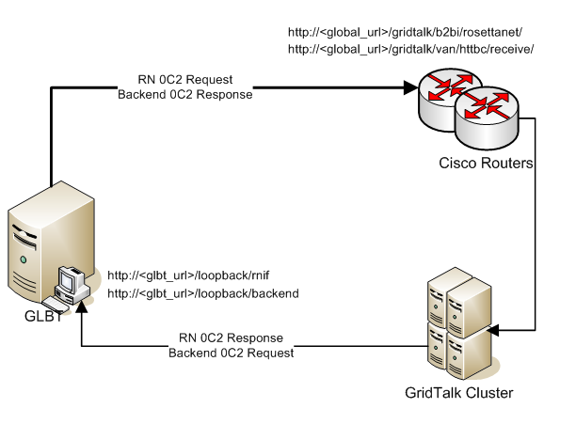
Figure 2.1 Network Topology for GridTalk Loopback Tester

GLBT will send documents to the public URLs of GridTalk while the latter can send documents directly to the internal URLs of GLBT.

Sending to the public GridTalk URLs will simulate documents coming from both GridTalk RN Partners and Backend Customers whereas restricting access to GLBT URLs (on the LAN) reduces risks of network security breaches.

Note | GLBT can be made available on public URLs if required. Related security risks are not discussed here.

Pre-requisites

Software
Software | Purpose
Java Runtime Environment (Sun JRE) | To run GLBT as a Java application
Windows Manager (FireDaemon) | To run GLBT as a Windows service

Directory Paths
Reference in this document | Purpose
<GLBT_HOME> | Installation directory of Jetty

Installation Files
File | Purpose
jetty-6.1.1.zip | Jetty distribution
glbt-1.0.zip | GLBT distribution

Installation and Configuration
This section guides the reader on the installation and configuration tasks of GLBT.

Installation

Jetty
Jetty is a third-party software and distributed as a zipped file.
- Download Jetty distribution from the Jetty website.
- Unzip it to a temporary directory.
- Copy ALL the contents of the unzipped Jetty folder to <GLBT_HOME>.

GLBT
GLBT is packaged as a zipped file named glbt-<version_num>.zip.
- Obtain the GLBT distribution from GridNode.
- Unzip it to a temporary directory.
- Copy ALL the contents of the unzipped GLBT folder to <GLBT_HOME>. Click ‘Yes/OK’ to overwrite folders/files if prompted.

GLBT Directory Structure
The following sample screenshot shows the directory structure after installation of Jetty and GLBT.

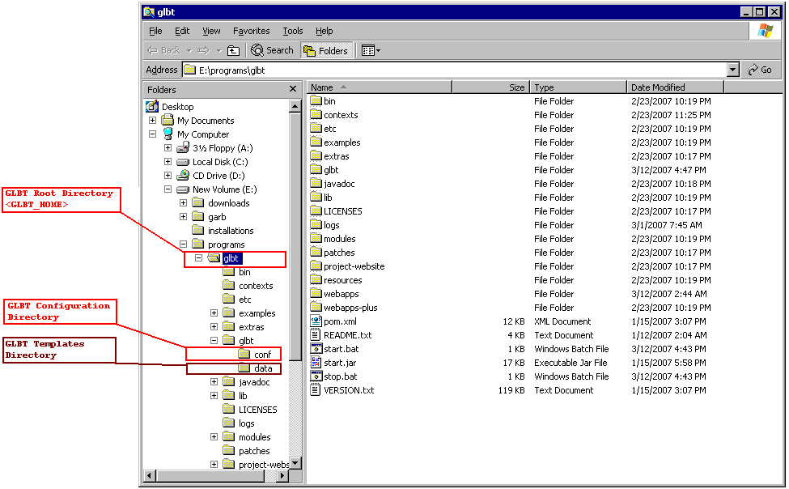
Figure 3.2 GLBT Directory Structure

Note | In Figure 3.2 above, <GLBT_HOME> resolves to E:\programs\glbt. This might be different on the deployment server.

Windows Service
FireDaemon is used as the Windows Service Manager to register and run GLBT as a Windows service.
- Open the FireDaemon console.
- Create a new service for GLBT by specifying the following service definition parameters:
Service Definition | Value
Start-up Working Directory | <GLBT_HOME>
Start-up Executable | <GLBT_HOME>/start.bat
Shutdown Working Directory | <GLBT_HOME>
Shutdown Executable | <GLBT_HOME>/stop.bat

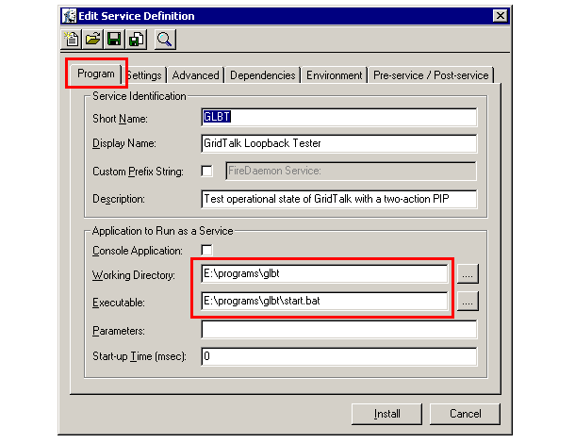
Figure 3.3 FireDaemon Service Start-up

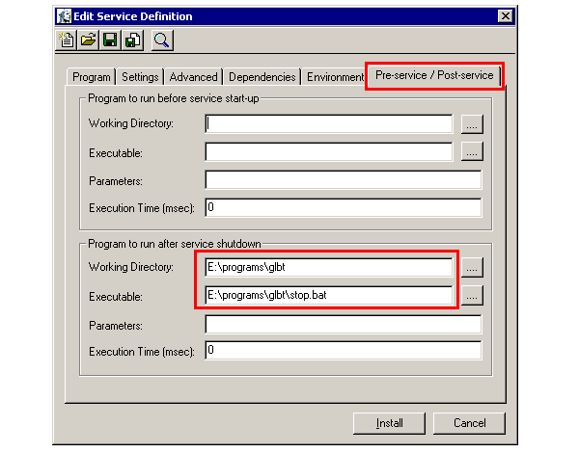
Figure 3.4 FireDaemon Service Shutdown

- Save the new Windows Service.

Configuration

Jetty Port
By default, Jetty is configured to open and listen on port 8080. If this needs to be changed, follow the instructions below:
- Edit <GLBT_HOME>/etc/jetty.xml.
- Modify the following port number in RED as required:
<Configure id="Server" class="org.mortbay.jetty.Server">
...
<Call name="addConnector">
...
<Arg>
...
<New class="org.mortbay.jetty.nio.SelectChannelConnector">
...
<Set name="port"><SystemProperty name="jetty.port" default="8080"/></Set>
...
</New>
...
</Arg>
...
</Call>
...
</Configure>

- Save and close the file.

GLBT Main Configuration
Configure the GLBT main configuration as follows:
File: <GLBT_HOME>/glbt/conf/main.conf
Parameter | Value | Remarks
heartbeat.interval | 0 | Disabled
test.interval | 0 | Disabled
inbound.test.timeout | 0 | Disabled
outbound.test.timeout | 0 | Disabled

GridTalk Test Partner
Configure GLBT test partner configuration as follows:
File: <GLBT_HOME>/glbt/conf/partner.conf
Parameter | Value | Remarks
Duns | 888888888 | This must match the configured test partner DUNS in GridTalk
partner.id | loopback | This must match the configured test RN partner’s Partner ID in GridTalk
gridtalk.rn.url | http://<global_url>/gridtalk/b2bi/rosettanet | Specify full domain name/IP if GLBT and GridTalk are in different domains.
pip.code | 0C2

GridTalk Test Backend Customer
Configure GLBT test backend customer as follows:
File: <GLBT_HOME>/glbt/conf/backend.conf
Parameter | Value | Remarks
duns | 999999999 | This must match the configured test backend customer’s DUNS in GridTalk
be.id | TBKN | This must match the configured test backend customer’s Business Entity ID in GridTalk
httpbc.url | http://<global_url>/gridtalk/van/httpbc/receive | Specify the full domain name/IP if GLBT and GridTalk are in different domains.
doc.type | 0C2

Log
GLBT log files are located in <GLBT_HOME>/glbt/log
There is no modification to be made to the default configurations.

Other Configurations
GridTalk
GridTalk needs to be configured to communicate with the GLBT as its test partner as well as its test backend customer.

See Section 6.1 Appendix I – GridTalk 0C2 Configuration for GLBT.

Transaction Monitoring
Create a group name for the test backend customer business entity Id in the transaction monitoring system so that the relevant transactions are successfully recorded.

Removal
The removal of GLBT from any system mainly involves shutting down the service (if required) and deleting the <GLBT_HOME> directory.

Instructions
- Stop the GLBT service from FireDaemon or Windows Services Management Console.
- Using FireDaemon, remove the GLBT Windows service.
- Back up a copy of <GLBT_HOME> if required.
- Delete <GLBT_HOME> directory.

Appendices

Appendix I – GridTalk 0C2 Configuration for GLBT

Communication Tab

Packaging Profile
Go to Admin→Communication→Packaging Profile→Create Packaging Profile
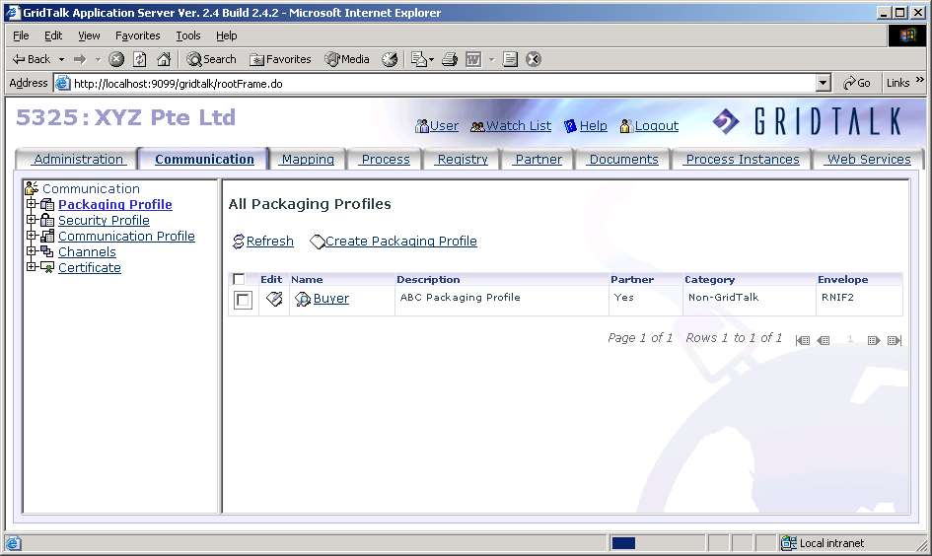

Field | Value
Name | Buyer
Description | Buyer Packaging Profile
Partner | TRUE
Envelope | RNIF2

Security Profile
Go to Admin→Communication→Security Profile→Create Security Profile
Field | Value
Name | Buyer
Description | Buyer Security Profile
Partner | TRUE
Encryption Type | NONE
Signature Type | NONE
Compression Type | NONE

Communication Profile
Go to Admin→Communication→Communication Profile→Create Communication Profile
Field | Value
Name | Buyer
Description | Buyer Communication Profile
Partner | TRUE
Protocol Type | HTTP
Url | http://<glbt_url>/loopback/rnif

Channels
Go to Admin→Communication→Channels→Create Channel Info
Field | Value
Name | Buyer
Description | Buyer Communication Profile
Protocol Type | HTTP
Partner | TRUE
Communication Profile | Buyer
Packaging Profile | Buyer
Security Profile | Buyer

Registry Tab

Go to Admin→Registry

Business Entity

Own Business Entity
Go to Admin→Registry→Business Entities→Create Business Entity
Field | Value
Business Entity
Id | TBKN
Description | Backend Default Business Entity
Partner | FALSE
Channel
White Page
Business Desc | Seller
DUNS | 999999999
Supply Chain Code | Electronic Components
Country | Singapore
Language | English

Partner Business Entity
Go to Admin→Registry→Business Entities→Create Business Entity
Field | Value
Business Entity
Id | LOOP
Description | Buyer
Partner | TRUE
Channel | Buyer
White Page
Business Desc | Buyer
DUNS | 888888888
Supply Chain Code | Electronic Components
Country | Singapore
Language | English

Partner Tab
Go to Admin→Partner

Partner Types
Go to Admin→Partner→Partner Types→Create Partner Type
Field | Value
Partner Type | CU
Description | Customer

Partner Groups
Go to Admin→ Partner→Partner Groups→Create Partner Group
Field | Value
Partner Group | LC
Description | Local Customer
Partner Type | CU

Partners
Go to Admin→Partner→Create Partner
Field | Value
Partner ID | loopback
Name | Buyer
Description | Buyer
State | Enabled
Partner Type | CU
Partner Group | LC
Business Entity | LOOP
Channel | Buyer

Mapping Tab
Go to Admin→Mapping

Document type
Go to Admin→Mapping→Document Type→Create Document Type
Field | Value
Document Type | 0C2
Description | 0C2

Mapping Files

DTD
Go to Admin→Mapping→Mapping Files→ Create Mapping File
Field | Value
Name | OC2R _DTD
Description | 0C2R_MS_V02_Asynchronous_Test_Request
Filename | 0C2_MS_R01_01_AsynchronousTestRequest_1.dtd
Type | DTD

Field | Value
Name | OC2C _DTD
Description | 0C2C_MS_V02_Asynchronous_Test_Confirmation
Filename | 0C2_MS_R01_01_AsynchronousTest Confirmation _1.dtd
Type | DTD

Note | The DTD files with the above-mentioned file names must be imported from the local system. These files are available from RosettaNet website.

Dictionary Files
Go to Admin→Mapping→Mapping Files→ Create Mapping File
Field | Value
Name | 0C2R_Dict
Description | 0C2R_MS_V02_02_Asynchronous_Test_Request
Filename | 0C2_MG_R01_01_00_AsynchronousTestRequest.xml
Type | Diction File

Field | Value
Name | 0C2C_Dict
Description | 0C2C_MS_V02_02_Asynchronous_Test_Confirmation
Filename | 0C2_MG_R01_01_00_AsynchronousTestConfirmation.xml
Type | Diction File

Note | The Dictionary files with the above-mentioned file names must be imported from the local system. These files are available from RosettaNet website.

Process Tab
Go to Admin→Process

Process Definition
Go Admin→Process→Process Definition→Create Process Definition
Field | Value
General
Name | 0C2
Is Synchronous | FALSE
Process Type | Double Action Process
Action Time Out (in sec.) | 86400
RNIF Version | RNIF 2.0
PIP Process Code | 0C2
PIP Version | R01.01
Usage Code | Test
From
Partner Class Code | Manufacturer
Partner Role Class Code | Account Supplier
Business Service Code | Supplier Service
To
Partner Class Code | Manufacturer
Partner Role Class Code | Account Seller
Business Service Code | Seller Service
Document Identifier
Request Document This Document Identifier: | /Pip0C2AsynchronousTestRequest/thisDocumentIdentifier/ProprietaryDocumentIdentifier
Response Document This Document Identifier: | /Pip0C2AsynchronousTestConfirmation/thisDocumentIdentifier/ProprietaryDocumentIdentifier
Response Document Request Document Identifier: | /Pip0C2AsynchronousTestConfirmation/requestingDocumentIdentifier/ProprietaryDocumentIdentifier

Note | Do NOT click ‘Save Process Definition’ yet. See next steps

Go to Edit Request Action Configurations
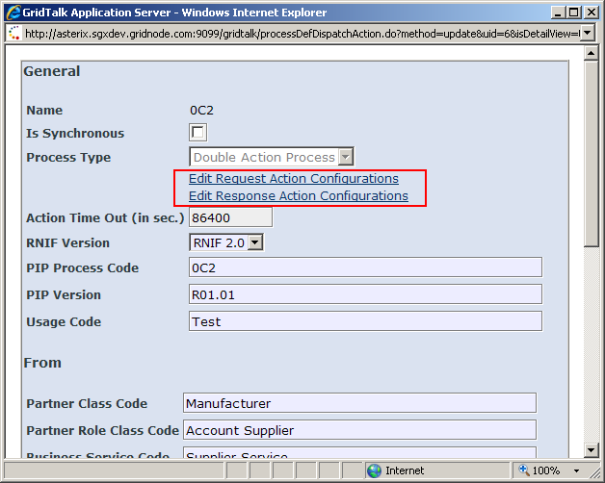

Field | Value
Files
Message Type | 0C2R_DTD
Diction File
XML Schema
Details
Business Activity Identifier: | Asynchronous Test Request
Business Action Code: | Asynchronous Test Request Action
Retries | 3
Time To Acknowledge (in secs) | 7200
Options
Is Authorization Required | TRUE
Is Non-Repudiation Required | TRUE
Is Secure Transport Required | TRUE
Disable DTD | TRUE
Disable Schema | TRUE
Validate At Sender | FALSE
Encryption
Disable Encryption | TRUE
Disable Signature | TRUE
Only Encrypt Payload | FALSE
Digest Algorithm | SHA1
Encryption Algorithm | 3DES_EDE/CBC/PKCS5Padding
Encryption Algorithm Length: | 168

Go to Edit Response Action Configurations
Field | Value
Files
Message Type | 0C2C_DTD
Diction File
XML Schema
Details
Business Activity Identifier: | Asynchronous Test Confirmation
Business Action Code: | Asynchronous Test Confirmation Action
Retries | 3
Time To Acknowledge (in secs) | 7200
Options
Is Authorization Required | TRUE
Is Non-Repudiation Required | TRUE
Is Secure Transport Required | TRUE
Disable DTD | TRUE
Disable Schema | TRUE
Validate At Sender | FALSE
Encryption
Disable Encryption | TRUE
Disable Signature | TRUE
Only Encrypt Payload | FALSE
Digest Algorithm | SHA1
Encryption Algorithm | 3DES_EDE/CBC/PKCS5Padding
Encryption Algorithm Length: | 168

Procedure Definition Files
Go to Admin→Process→Procedure Definition files→Create Procedure Definition files

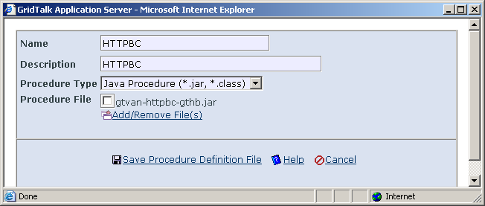

Field | Value
Name | HTTPBC
Description | HTTPBC
Procedure Type | Java Procedure {*.jar, *.class)
Procedure File | gtvan-httpbc-gthb.jar

Note | The Procedure File must be imported from the local system. It is available in the zipped user procedure file from the GridTalk release package

User Procedure
Go to Admin→Process→User Procedure→Create User Procedure
Field | Value
Name | PUSH2CUST_HTTP
Description Type | Push doc to customer HTTP
Procedure Type | Java Procedure {*.jar, *.class)
Procedure Definition File | HTTPBC

Go to Create Procedure Parameter Configuration

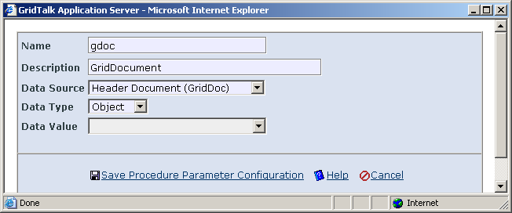

Field | Value
Name | gdoc
Description | GridDocument
Data Source | Header Document (GridDoc)
Data Type | Object
Data Value

Field | Value
Name | udoc
Description | User doc byte content
Data Source | Embedded Document (UserDoc)
Data Type | byte[]
Data Value

Field | Value
Name | attachments
Description | attachments byte content
Data Source | Attachments
Data Type | byte[][]
Data Value

Field | Value
Name | attFilesName
Description | Attachment filenames
Data Source | Attachments
Data Type | String[]
Data Value | Original filename

Field | Value
Name | config
Description | destination config
Data Source | User Defined
Data Type | String
Data Value | <GRIDTALK_HOME>/data/GNapps/gtvan/httpbc/jms_intx.properties

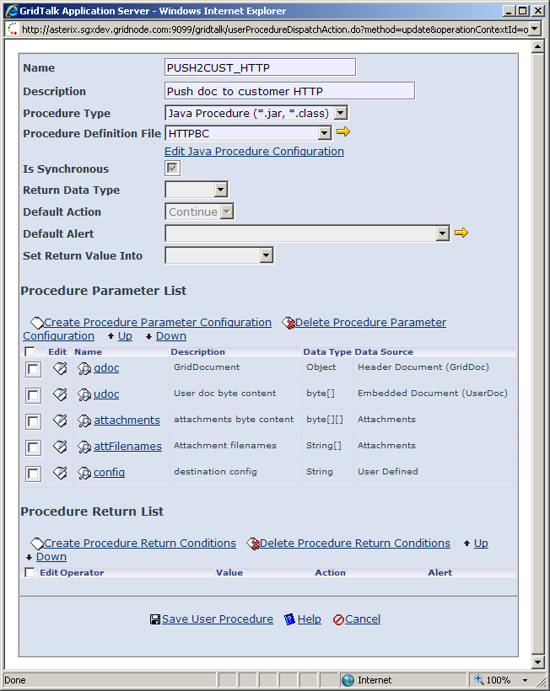

Click on Edit Java Procedure Configuration
Field | Value
Class Name | com.gridnode.gridtalk.httpbc.gthb.AsyncBackendPush
Execute within Application VM | True
Method Name | void pushDocument(java.lang.Object gdocObj, byte[] udoc, byte[][] attachments, java.lang.String[] attFilenames, java.lang.String config)

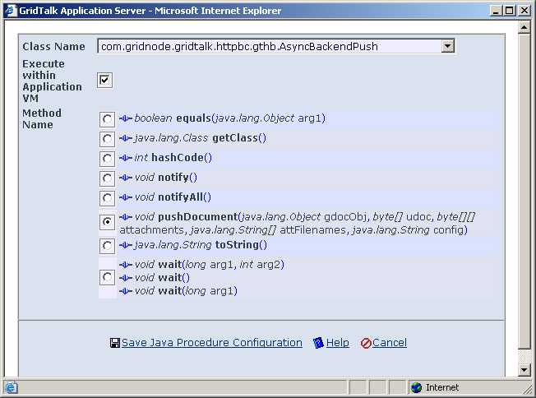

Partner Functions

0C2_IN
Go Admin→Process→Partner Functions→Create Partner Functions

Field | Value
Id | 0C2_IN
Description | Inbound Partner Function for 0C2 from Buyer
Trigger On | Receive

Steps to Create the Workflow Activities:
Field | Value
Activity 1 | Click On Create Workflow Activity  Select Activity Type: Exit to export  Click “Save Workflow Activity(s)”
Activity 2 | Click On Create Workflow Activity  Select Activity Type: Save to Folder  Click “Save Workflow Activity(s)”
Activity 3 | Click On Create Workflow Activity  Select Activity Type: User Procedure  Select User Procedures: PUSH2CUST_HTTP  Click on “Save Workflow Activity(s)”
Activity 4 | Click On Create Workflow Activity  Select Activity Type: Exit Workflow  Click “Save Workflow Activity(s)”

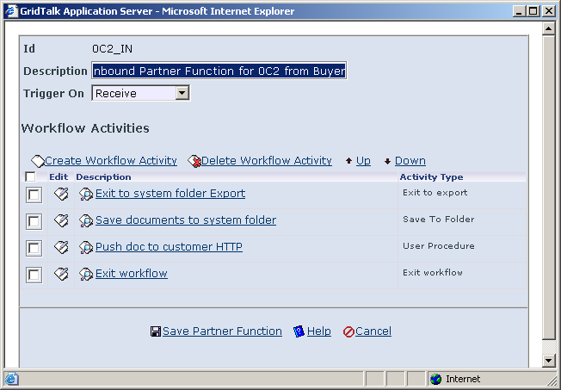

0C2_OUT
Go Admin→Process→Partner Functions→Create Partner Functions
Field | Value
Id | 0C2_OUT
Description | 0C2 to Buyer
Trigger On | Import

Steps to Create the Workflow Activities:
Field | Value
Activity 1 | Click On Create Workflow Activity  Select Activity Type: Exit to Outbound  Click “Save Workflow Activity(s)”
Activity 2 | Click On Create Workflow Activity  Select Activity Type: Exit to Channel  Click “Save Workflow Activity(s)”
Activity 3 | Click On Create Workflow Activity  Select Activity Type: Exit Workflow  Click on “Save Workflow Activity(s)”

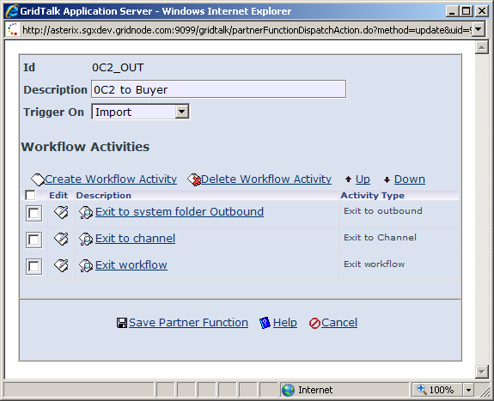

Trigger

Go Admin→Process→Trigger→Level 1→Create Trigger

0C2_IN
Field | Value
Trigger Type | Receive
Trigger Level | level 1
Partner Function | 0C2_IN
Document Type | 0C2

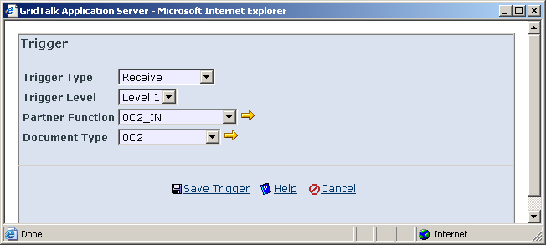

0C2_OUT
Field | Value
Trigger
Trigger Type | Import
Trigger Level | level 1
Partner Function | 0C2_OUT
Document Type | 0C2
Process Definition
Process Definition | 0C2
Is Request | False

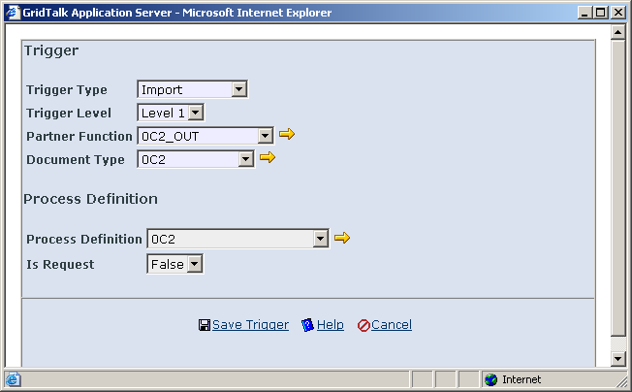

Process Mapping
Go Admin→Process→Process Mappings→Create Process Mapping
Field | Value
Process to Map | 0C2
Partner | Buyer
Participating In | Responding Role
Channel | Buyer Communication Profile
Document Type | 0C2

Database Records
The user should login to GTVAN. Here is the sample connection command (run in Oracle Client):

CONNECT GTVAN/gridnode@<DB_machine_ip_address>:<DB_port>/<DB_service_name>

INSERT INTO "config_props" ("category", "property_key", "value")
VALUES ('http.target.conn.TBKN','target.http.url','http://<glbt_url>/loopback/backend');

Refer to GridTalk Topology from the GridTalk Deployment Guide document
http://dist.codehaus.org/jetty/jetty-6.1.1.zip
Refer to Section 2.2.2 Directory Paths

